Overview - Attention Mechanism and Transformers

[Previous](https://olympus.mygreatlearning.com/courses/111352/modules/items/5520653?pb_id=17388)

[Next](https://olympus.mygreatlearning.com/courses/111352/modules/items/5520656?pb_id=17388)

#### [NLP_Upt-Week-3-Journey-Map.png](https://olympus.mygreatlearning.com/courses/111352/modules/items/5520656?pb_id=17388)

#### **QUICK RECAP**

In the previous week, we learned about what are word embeddings and types of word embeddings. Let us quickly recap what we have covered so far.

* Introduction to word embeddings
* Word2Vec
* CBOW and Skip-gram
* Negative Sampling
* GloVe
* Applications of Word Embeddings

#### **COURSE OVERVIEW**

**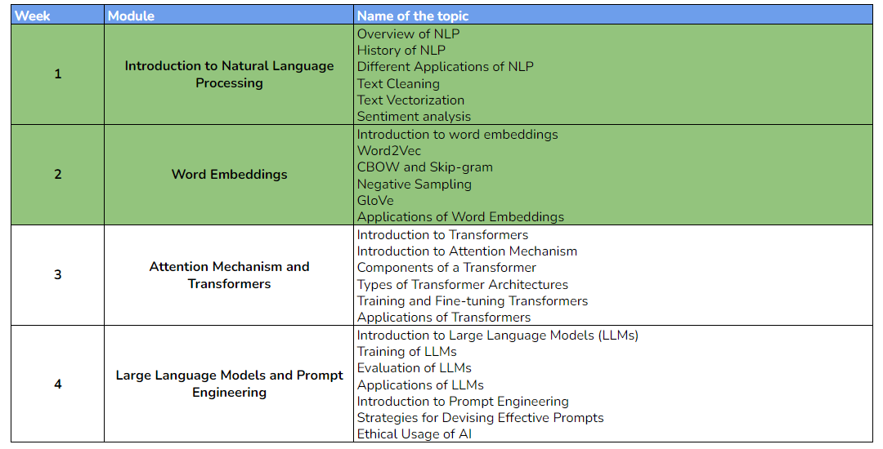**

#### **WEEK 3 OVERVIEW**

This week, we will be learning about transformers, how they utilize the concept of self-attention, and different transformer architectures. The following topics will be covered in this module:

* Introduction to Transformers
* Introduction to Attention Mechanism
* Components of a Transformer
* Types of Transformer Architectures
* Training and Fine-tuning Transformers
* Applications of Transformers

#### **LEARNING INSTRUMENTS**

| **Week** | **Module** | **No. of Videos** | **Total Duration** | **No. of Test Your Understanding Quizzes** | **No. of Graded Quizzes** | **No. of Practice Assignments** |
| --- | --- | --- | --- | --- | --- | --- |
| 1 | Attention Mechanism and Transformers | 11 | ~2.5 hours | 11 | 1 | 1 |

#### **Note:** It is recommended to spend at least 1 hour/day along with practicing datasets and quizzes.

**Power Ahead!**